Operation Manual

HMCXZ-16875kVA/225kV
Variable Frequency Resonant Test System

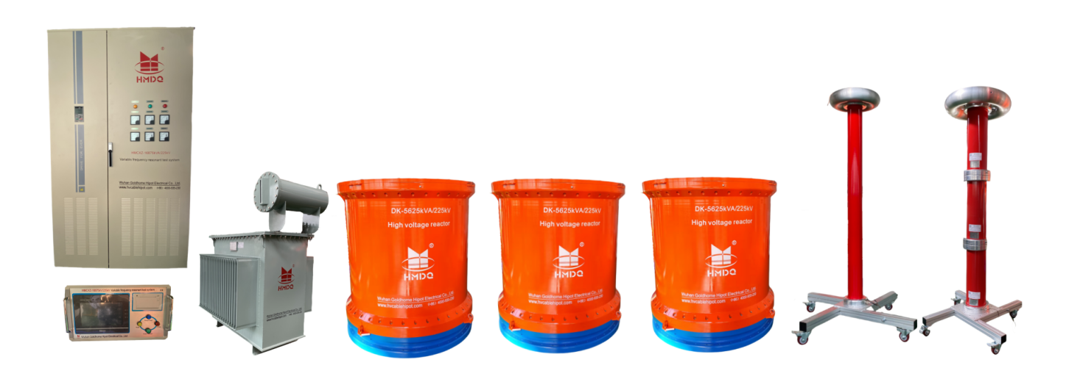

Dear Customer

Thank you for purchasing our series resonance device. Before you use this product for the first time, please read this instruction manual in detail, which may help you to use this instrument proficiently.

Our aim is to continuously improve and perfect our products, so the product you use may be slightly different from the instruction manual. If there are any changes, we will inform you in the form of an attached page, please understand! If you have any questions, please contact the company's after-sales service department, we will definitely meet your requirements.


Warning!

Since the input and output terminals, test posts, etc. may carry voltage, sparks may be generated when you plug in or unplug the test wires or power sockets. Be careful of electric shocks and avoid the risk of electric shock. Pay attention to personal safety!

Warning!

During the test, the reactor cannot be placed on a metal or metal mesh prefabricated ground, otherwise the variable frequency power supply may not find the resonance point, and the reactor will generate eddy currents, resulting in a decrease in the Q value. In severe cases, the reactor will have a sharp temperature rise due to the eddy currents, causing the internal coil to burn out.
After each test, please be sure to cut off the variable frequency power supply control power supply (air switch) to ensure that there is no voltage output before the next test or the end of the test.

Safety requirements
Please read the following safety precautions to avoid personal injury and prevent damage to this product or any other products connected to it. To avoid possible dangers, this product can only be used within the specified range.

- Only qualified technicians can perform maintenance!
- Prevent fire or personal injury!
- The grounding resistance must be less than 2Ω. If it is higher than 2Ω, it may damage the series resonance test system. The grounding can be directly connected to the grid system grounding.

- Use the appropriate power cord: Only use the power cord dedicated to this product and in accordance with the specifications of this product.
- Connect and disconnect correctly: When the test lead is connected to the live terminal, do not connect or disconnect the test lead at will.
- Product grounding: In addition to grounding through the power cord grounding wire, the grounding pole of the product housing must be grounded. To prevent electric shock, the grounding conductor must be connected to the ground. Before connecting to the input or output terminals of this product, make sure that this product is properly grounded.
- Pay attention to the ratings of all terminals: To prevent fire or electric shock hazards, pay attention to all ratings and markings of this product. Before connecting this product, please read the user manual of this product for further information about the ratings.
- Do not operate without the instrument cover: Do not operate this product if the cover or panel has been removed.
- Do not operate if there is a suspected fault: If you suspect that the product is damaged, please ask our maintenance personnel to check it and do not continue to operate it.
- Do not operate in a humid environment.
- Do not operate in an explosive environment.
- Keep the product surface clean and dry.

Content
Safety requirements 2
I Brief introduction 7
II Technical parameters of system 7
III Characteristics of System 9
IV Application of system 11
V Introduction of system 12
1. Variable frequency power supply 12
2. Excitation transformer 14
3. High voltage reactor 15
4. Capacitor voltage divider 16
5. Resonance compensation capacitor 17
V Operation of system 18
1. Main interface of the test system 18
2. Parameter Setting 18
3. Manual Test 20
4. Automatic Test 21
5. File 22
VI Attention 23
VII Common faults and troubleshooting 23

I Brief introduction

This test system is mainly designed and manufactured for AC withstand voltage testing of 69kV, 138kV, 230kV cables and power systems. The reactor adopts multiple separate designs, which can meet the requirements of high voltage and low current equipment testing conditions. It is an ideal withstand voltage equipment for local, municipal, and county-level high-voltage testing departments and power installation and repair engineering units. The device mainly consists of a variable frequency control power supply, excitation transformer, high-voltage reactor, and capacitor voltage divider.

This equipment is the fourth generation AC withstand voltage resonance test device upgraded by our company's many years of production experience and market customer feedback. It is different from the previous equipment with black and white screen touch analog digital processing control sensitivity and low input power selection. The human-machine interface of the fourth generation AC withstand voltage resonance test device adopts 32-bit RISC CPU and streamlined LINX core, 7-inch touch screen true color graphic format, test resonance frequency curve, boost curve, timing curve display, high voltage current, high voltage voltage, low voltage current true effective value digital feedback on the interface, resonance frequency calculation, test product resonance capacitance calculation results, protection function, low voltage current, high voltage voltage, flashover voltage protection function is more sensitive.

II Technical parameters of system
- Rated capacity: 16875kVA
- Input power supply: three-phase 380V voltage, frequency 60Hz
- Rated voltage: 225kV
- Rated current: 75A
- Working frequency: 20-300Hz
- Waveform distortion rate: Output voltage waveform distortion rate ≤ 1%
- Duration: Allow continuous 60 minutes under rated load（60 minutes of work and 60 minutes of rest）
- Temperature rise: After continuous operation for 180 minutes under rated load, the temperature rise is ≤ 65K
- Quality factor: Device Q ≥ 30 (f=45Hz)
- Protection function: It provides overcurrent, overvoltage, and sample flashover protection for the test object (see the variable frequency power supply section for details)
- Measurement accuracy: System RMS 1.5 level
- Working environment:
- Temperature: -15℃-45℃
- Relative humidity: ≤ 90% RH
- Altitude: ≤ 2500 meters
- Relationship list during experiment

Equipment  combinatiTested object |  | Reactor  5625kVA/225kV-3 unit | Excitation transformer  Output selection
69 kV cable, 0.21μF/km | Length  5000m | 1 unit | 2kV
138 kV cable, 0.32μF/km | Length  5000m | 2 unit in Parallel | 4kV
230 kV cable, 0.27μF/km | Length  5000m | 3 units in Parallel | 6kV

III Characteristics of System

- The required power capacity is greatly reduced. The series resonant power supply uses the resonance of the resonant reactor and the capacitor of the test object to generate high voltage and large current. In the entire system, the power supply only needs to provide the active power consumption part of the system. Therefore, the power required for the test is only 1/Q of the test capacity.
- The weight and volume of the equipment are greatly reduced. In the series resonant power supply, not only the bulky high-power voltage regulator and the ordinary high-power power frequency test transformer are eliminated, but also the resonant excitation power supply only needs 1/Q of the test capacity, which greatly reduces the weight and volume of the system, generally 1/10-1/30 of the ordinary test device.
- Improve the waveform of the output voltage. The resonant power supply is a resonant filter circuit that can improve the waveform distortion of the output voltage, obtain a good sine waveform, and effectively prevent the harmonic peak from accidentally breaking down the test object.
- Prevent large short-circuit current from burning the fault point. In the series resonant state, when the insulation weakness of the test object is broken down, the circuit is immediately detuned and the loop current drops rapidly to 1/Q of the normal test current. When the parallel resonance or test transformer method is used for withstand voltage test, the breakdown current immediately rises by dozens of times. Compared with the two, the short-circuit current is hundreds of times different from the breakdown current. Therefore, series resonance can effectively find insulation weaknesses, and there is no worry about large short-circuit current burning the fault point.
- There will be no recovery overvoltage. When the test product breaks down, the high voltage disappears immediately due to the loss of resonance conditions, the arc is extinguished immediately, and the recovery voltage re-establishment process is very long. It is easy to disconnect the power supply before reaching the flashover voltage again. This voltage recovery process is an intermittent oscillation process of energy accumulation. The process is long, and there will be no recovery overvoltage.
- The device has protection functions such as overvoltage, overcurrent, zero-position start, system detuning, and high-voltage flashover fault. The overvoltage and overcurrent protection values can be adjusted according to user needs. When the test product flashes, the flashover protection is activated and the flashover voltage value can be recorded for test analysis.
- The device has two working modes, which allows users to flexibly choose according to the on-site conditions and improve the test speed. The working modes are: fully automatic mode, manual mode.
- It can store timely and printing data. The stored data number is the testing time, which is convenient for users to identify and find.
- When the device automatically sweeps the frequency, the frequency starting point can be set arbitrarily within the specified range, and the sweep direction can be selected up or down. At the same time, the large color LCD screen displays the scanning resonance, boost, and timing curves, which is convenient for users to intuitively understand whether the resonance point is found.
- The DSP platform technology is adopted, which can easily increase or decrease functions and upgrade according to user needs, and also makes the human-computer exchange interface more user-friendly.

IV Application of system
- AC withstand voltage test of 5km long 69kV power cable, capacitance 0.21μF/1km, test frequency 20-300Hz, test voltage 72kV, test time 60min/phase.
*Use 1 reactor, inductance is 36H.
Test frequency f=1/2π√LC=1/(2×3.14×√36×1.05×10⁻⁶)=25.9Hz
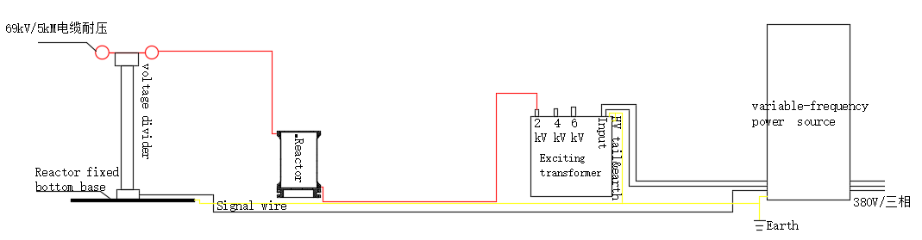
Test current I=2πfCU_{试}=2π×25.9×1.05×10⁻⁶×72×10³=10.3A

- AC withstand voltage test of 5km long 138kV power cable, capacitance 0.32μF/1km, test frequency 20-300Hz, test voltage 132kV, test time 60min/phase.
*Use 2 reactors in parallel, inductance is 36H/2=18H.
Test frequency f=1/2π√LC=1/(2×3.14×√8×1.6×10⁻⁶)=29.6Hz
Test current I=2πfCU_{试}=2π×29.6×1.6×10⁻⁶×132×10³=39.3A
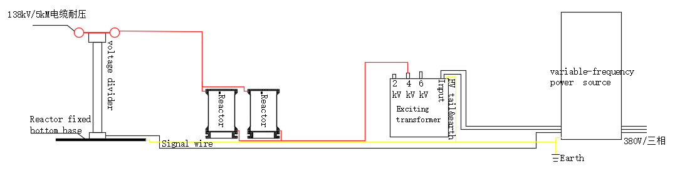

- AC withstand voltage test of 5km long 230kV power cable, capacitance 0.27μF/1km, test frequency 20-300Hz, test voltage 216kV, test time 60min/phase.
*Use 3 reactors in parallel, inductance is 36H/3=12H.
Test frequency f=1/2π√LC=1/(2×3.14×√12×1.35×10⁻⁶)=39.5Hz
Test current I=2πfCU_{试}=2π×39.5×1.35×10⁻⁶×216×10³=72.4A
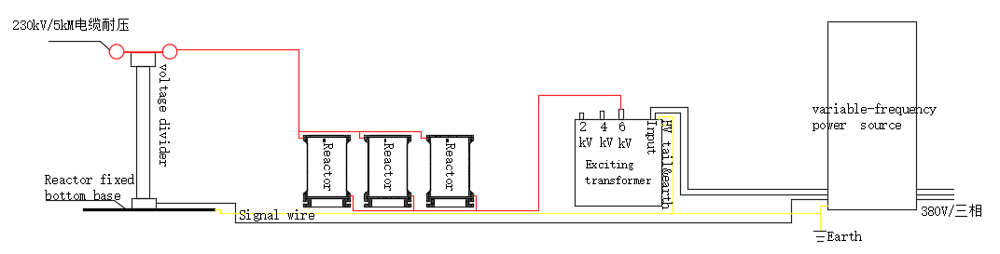

V Introduction of system
- Variable frequency power supply-CHXB-700kW/0.38kV
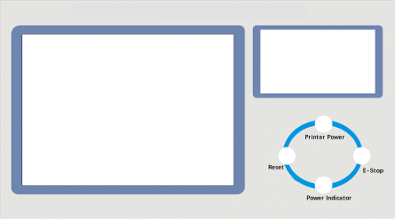

No. | Terminal | Connection
1 | POWER SOCKET | Connect with “power socket” of power supply cabinet
2 | SIGNAL SOCKET | Connect with “signal socket” of power supply cabinet
3 | PE | Grounding
4 | USB Port | USB communication for upload test datas

- The USB should connect with control box before power on, or the test result can not be upload.
No. | Function Button | Function
1 | Print Power | Printer swich of the controller
2 | E-Stop | Emergency stop
3 | Reset | Reset of the power supply cabinet

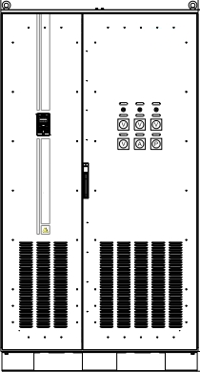

No. | Terminal | Connection
1 | R | Connect with 3 phase power supply  ( position: inside of the cabinet)
2 | S
3 | T
4 | U | Connect with input of the excitation transformer  ( position: inside of the cabinet)
5 | W
6 |  | Grounding( position: inside of the cabinet)
7 | Power Socket | Connect with “power socket” of controller
8 | Signal Socket | Connect with “signal socket” of controller
9 | Divider Signal | Connect with “signal socket” of divider

    - After the line connection is completed, install the protective cover properly.
- Excitation transformer -JLB-450kVA/2kV/4kV/6kV/0.4kV
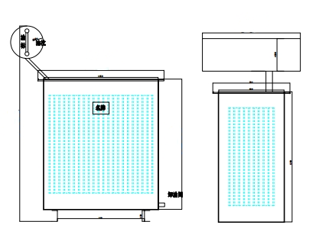

No. | Terminal | Connection
1 | 0V | Connect with output of the power supply of cabinet
2 | 400V(Optional) | Connect with output of the power supply of cabinet
3 | 500V(Optional) | Connect with output of the power supply of cabinet
4 | HV Tail/Grounding | Connect with grounding
5 | 2kV(Optional) | Connect with the HV reactor
6 | 4kV(Optional) | Connect with the HV reactor
7 | 6kV(Optional) | Connect with the HV reactor

- 400V and 500V are the input of the excitation transformer, the terminal will be chosen based on your test requirement.
- 2kV，4kV，6kV are the output of the excitation transformer, the terminal will be chosen on your test requirement.
- HV tail must be gounding in good condition.

- High voltage reactor -DK-5625kVA/75~225kV

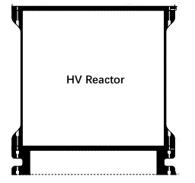
Ouput terminal

Input terminal

No. | Terminal | Connection
1 | Input (on the base) | Connect with output of the excitation transformer
2 | Output (on the top) | Connect with top of the divider

- Capacitor voltage divider -FCR-250kV/1000pF

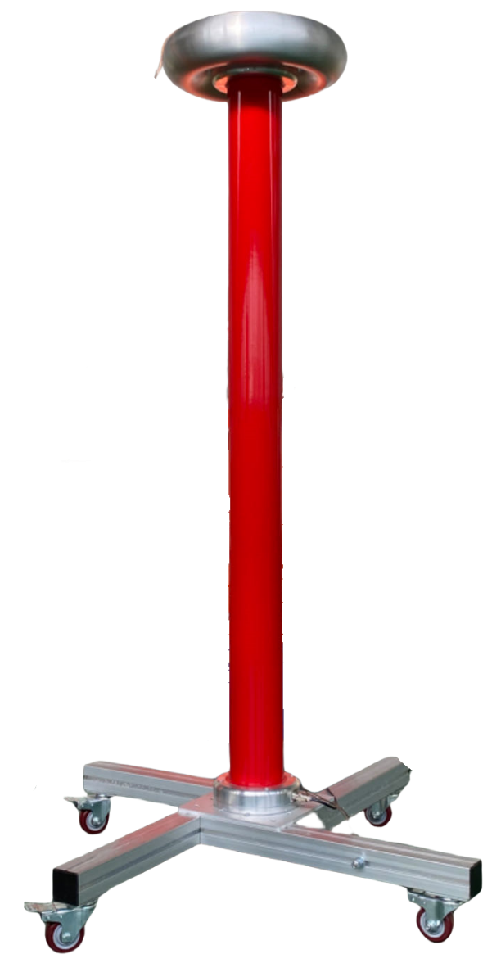
Output terminal

Grounding

Signal socket
Grounding

No. | Terminal | Connection
1 | Output (on the top) | Connect with output of the HV reactor
2 | Signal | Connect with the power supply cabinet
3 | Grounding( on the base) | There are 2 terminal of grounding, one is own to the  divider and the other is the base of it, all should be grounding well.

- Resonance compensation capacitor -XZC-75~225kV/75000~25000pF

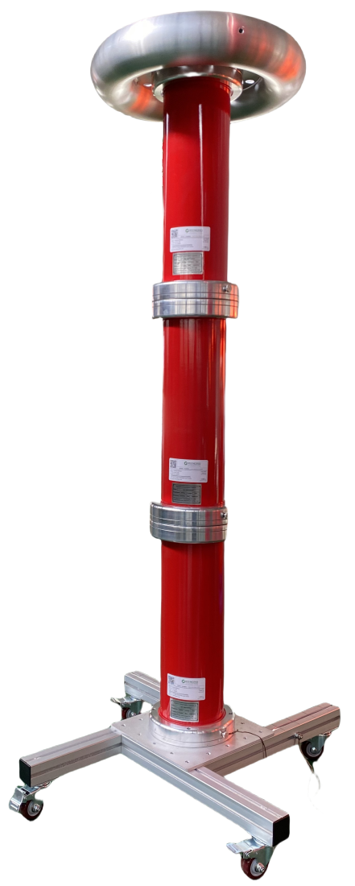
Output terminal

Grounding

Grounding

No. | Terminal | Connection
1 | Output (on the top) | Connect with top of the divider, or connect with the tested cable
2 | Grounding(on the base) | There are 2 terminal of grounding, one is own to the  compensation capacitor and the other is the base of it, all should be grounding well.

V Operation of system
- Main interface of the test system
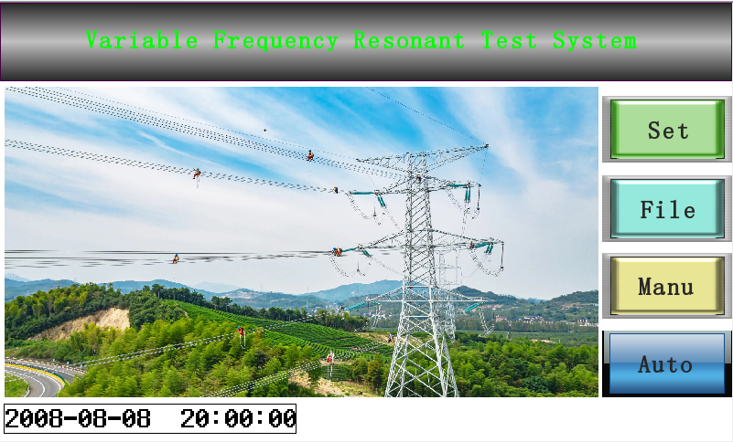

“Set”: Parameters Setting
“File”: Data Query
“Manu”: Manual Test
“Auto”: Automatic Test

- Parameter Setting
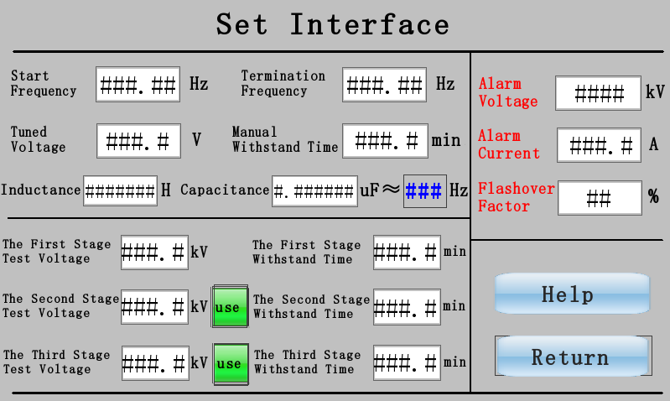

- “Start frequency” “Termination frequency”
* The frequency range is set to find the resonance point, usually we set the frequency range to start at 30Hz, termiation frequency at 300Hz.

- “Tuned Voltage”: based on your requirement, normally the range of it 20~100V.
- “Manual Withstand Time”: duration of the test

- “Inductance”: the inductance of the HV reactor
- “Capacitance”: the capacitance of the tested cable
* After inputting the inductance and capacitance, the formula will automatically calculate the approximate resonant frequency.

- “The first stage test voltage”: withstand voltage based on your requirement.
- “The first stage withstand time”: duration based on your requirement.
- “The second stage test voltage”: withstand voltage based on your requirement.
- “The second stage withstand time”: duration based on your requirement.
- “The third stage test voltage”: withstand voltage based on your requirement.
- “The third stage withstand time”: duration based on your requirement.
* A three-stage withstand voltage test is designed here. If it is not needed, just select the first stage. Usually, cable testing only requires a stable output and does not require a segmented withstand voltage test.

- “Alarm voltage”: usually 1.1~1.2 times of the test voltage
- “Alarm current”: the rated current of the test system or according to the actual needs.
- “Flashover factor”: normally 30%.

- Manual Test
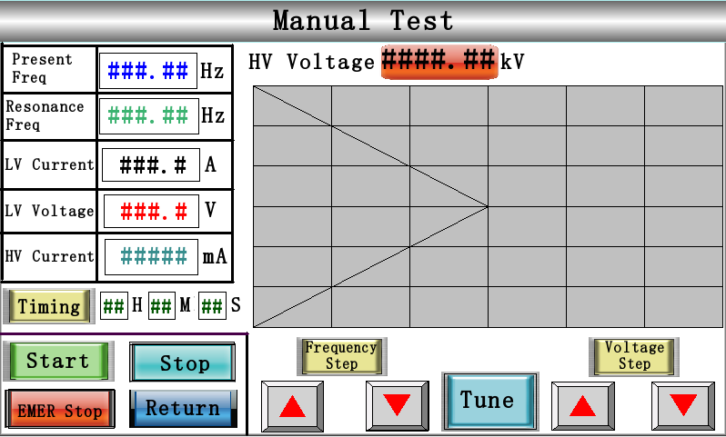
The Main Interface of The Manual Test

- After entering the manual test interface, click “Start”, the test system will ask whether to start, click Start as below:
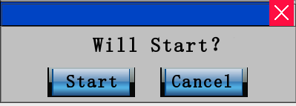

- Then click “Tune”
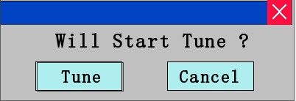

- At this point, the system begins to find the resonance point.
- When the present frequency and resonant frequency are the same, we can start boosting.


- “ Voltage step” : UP DOWN
- “Timing”: When the voltage rises to the test voltage we need, click Timing, the withstand voltage test starts.
- When the withstand voltage test is over, the system will pop up a window showing the end of the timing.
- Then, Click “Stop”, it will appear an window as below:
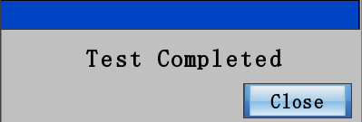

* You cannot click “Close” immediately on the interface at this time. You need to wait until the voltage returns to 0 before clicking close.

- The manual test is finished.

- Automatic Test
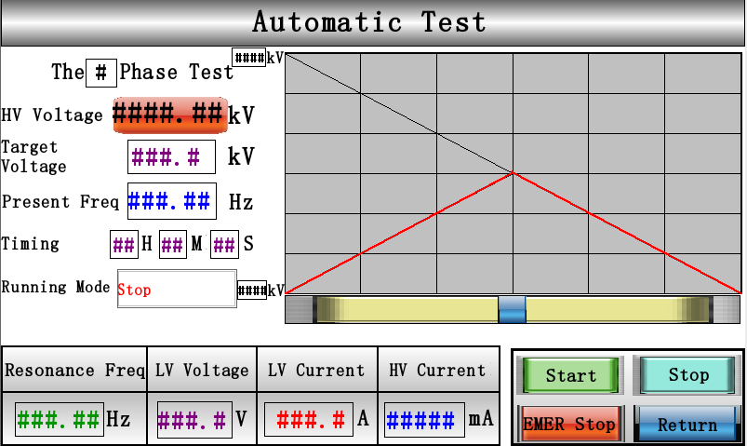

After parameters are setting well, click “Start”, the entire test process is automatically operated without manual operation, the operator only needs to monitor the equipment operation status.
- File

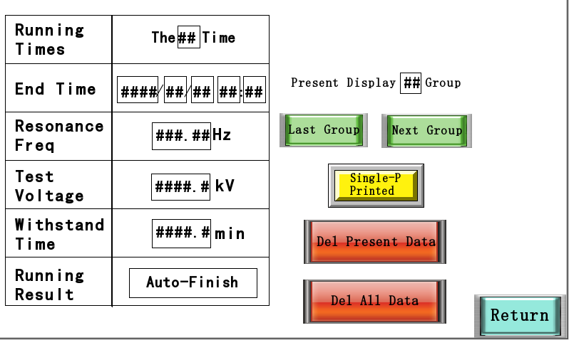
Interface of the File

* You’d better click “Print Power” (function button of the controller) before you print the test report directly.
* If you need to export data via USB, please be sure to insert the USB before starting the test, unplug it directly after the test, and view the data from the computer, as below:


①

The test data is in this folder.


Test data sorted by time
②
③

VI Attention
1. This test equipment should be used by professionals in high-voltage testing. Before use, the user manual should be carefully read and repeated operation training should be carried out.
2. There should be no less than 2 operators. When using, the safety operating procedures of the unit for high-voltage testing should be strictly followed.
3. In order to ensure the safety and correctness of the test, in addition to being familiar with this product manual, the test operation must also be strictly carried out in accordance with relevant national standards and regulations.
4. The connecting wires cannot be connected incorrectly, otherwise the test device may be damaged.
5. When this device is used, the output is high voltage or ultra-high voltage, which must be reliably grounded and pay attention to operating safety.

VII Common faults and troubleshooting
- The fan cannot start
- Reason: (1) After emergency stop, fault protection, and detuning protection, the "fault reset" button is not pressed; (2) The internal temperature is too high, and the power element is thermally protected;
- Troubleshooting method: Turn off the power of the instrument, let the instrument stand for about 30 minutes, turn on the power again, press the "reset" button on the instrument panel, and then start the instrument.
- If the fan still cannot be started, please contact the manufacturer. Do not disassemble the instrument.

- Automatic tuning cannot be completed and the resonance point cannot be found.
- Phenomenon: The tuning curve is a completely straight line. After the tuning is completed, the instrument prompts that there is no resonance point.
- Reason: The circuit grounding is not good, the test circuit wiring is wrong, and an instrument in the device is open.
- Troubleshooting method:
(1) Check whether the grounding device is reliable and whether the grounding connection line has a disconnection point;
(2) Check the continuity of the high and low voltage coils of the excitation transformer;
(3) Check the continuity of each reactor;
(4) Check the continuity of the signal line of the voltage divider;
(5) Check the continuity of the high and low voltage capacitor arms of the voltage divider;
(6) There is no resonance point when the device itself boosts the voltage, and it is also necessary to check the continuity of the compensation capacitor.
- If all components are normal and there is still no resonance point, please contact the manufacturer. Do not disassemble the instrument.

- Unable to boost to test voltage
- Phenomenon:
(1) The tuning curve is a curve with a lower peak;
(2) During the test, the primary voltage is higher, but the high voltage is lower. Even before the test voltage is raised, the primary voltage has reached the rated voltage, and the circuit automatically reduces the voltage.
- Reason:
(1) The capacitance of the reactor and the test product does not match, and the resonance point is not accurately found;
(2) The test product loss is high, and the system Q value is too low;
(3) The high voltage output voltage of the excitation transformer is low;
(4) The high voltage connection line is too long or the high voltage discharge line is not used.
- Troubleshooting methods:
(1) Connect the compensation capacitor to the test circuit to increase the circuit capacitance;
(2) Connect as many reactors in series as possible to increase the circuit inductance;
(3) Increase the output voltage of the excitation transformer;
(4) Dry the test sample to improve the insulation strength of the test sample and reduce the active power loss of the circuit;
(5) Generally, when the equipment outputs a higher voltage, use a high-voltage discharge line, or change the ordinary high-voltage output line to a shorter connection line, generally not more than 5 meters.
- If the problem still cannot be solved after all the treatments are completed, please contact the manufacturer. Do not disassemble the instrument.

