Operation Manual

HM-SLQ 6300A
Primary Current Injection Test Set

Content

Content 1
I Brief Introduction 2
II Characteristics Of Test System 2
III Technical Parameters 3
IV Diagram Of Test System 5
V Wire Connection 6
VI Operation Instruction 11
1. Main interface 11
2. Swithgear Temperature Rise Test 11
2.1 Auto Test 12
2.2 Manual Test 12
2.3 Test Data 13
3. Transformer Temperature Rise Test 13
3.1 Auto Test 14
3.2 Manual Test 14
3.3 Test Data 15
VII Maintenance 16
VIII Packing List Of Test System 16

I Brief Introduction
Configuration scheme of comprehensive test bench for power transformers with rated capacity of 1600~6300kVA, voltage of 10.5~33kV/400~800V, impedance ≤5.48~9% and below.

Test items:
1. Transformer No-load and Load test
2. Transformer temperature rise test
3. Busbar temperature rise test

No# | Component | Quantity
1 | Automatic Console | 1 set
2 | Power Compensation Unit | 1 set
3 | Primary Current Generator For Busbar | 1 set
4 | Temperature Rise Generator For Transformer | 1 set

II Characteristics Of Test System

- Electric induction voltage regulator
Contactless magnetic induction isolation voltage regulator transformer, worm gear stepper motor mechanical transmission adjusts voltage output, coarse and fine adjustable precise output.
﻿
- Three-phase current boost transformer
The current boost transformer adopts a fully insulated structure, T3 copper wire, and cold-rolled silicon steel plate. The transformer adopts double coils, low voltage input coil and high voltage output coil. Between low voltage and high voltage, low voltage and iron core, an electrostatic shield is placed. The high and low windings are magnetically coupled and there is no electrical connection.
﻿
- Intelligent electric control console
Control LCD screen sampling industrial computer, sampling signal board is a passive signal converter, multi-level isolation shielding protection, completely eliminate the destructive impact of high voltage breakdown direction voltage and direction current on the control power supply. The controller parameter setting does not need to be reset after power failure to make the same batch permanently saved, and the test data is permanently saved 500 times for easy reference and printing.

- 15.6-inch LCD touch screen display, human-machine interface, Mitsubishi PLC control, can print test data.
- High-precision sensor, Mitsubishi high-performance AD analog module, resolution up to 32000.
- Optional automatic current rise test, manual current rise test, flexible and simple operation.
- Real-time display of power supply voltage, power supply current, voltage regulator output voltage, output current, test product voltage, current, test time display function, test results, intuitive and clear display.
- Perfect overcurrent protection, arbitrarily set the target output current value, current upper limit and withstand time.
- The output current can be arbitrarily set and adjusted by the three-phase average value.
- It has a return to zero detection function, and the test can be carried out only after the return to zero is confirmed, which is safe and reliable.
- After reaching the set target output current, the current withstand timing is automatically adjusted. During the timing process, the current can be automatically adjusted to ensure that the test current is within the required range. After the timing is over, the voltage regulator motor automatically returns to zero, and the compensation capacitor contactor is fully disconnected.

III Technical Parameters
- Electric automatic console
It is mainly composed of transformer loss test unit, temperature test unit, manual/automatic control, and data processing of all test modules, and the data can be uploaded to the host computer. It is composed of digital voltage and current monitoring instruments, manual/automatic control of current and voltage rise and fall adjustment in the loss test part, and digital voltage and current monitoring instruments.

- Temperature rise test unit
- TSJA-150 three-phase induction electric voltage regulator, 1 unit
- Rated capacity: 150kVA
- Rated input voltage: three-phase 410V/50Hz(400~415V is allowed)
- Rated input current: 211.2A
- Rated output voltage: three-phase 25~650V/50Hz
- Rated output current: 133.2A

- Power compensation unit
- GLBC-400kVA power compensation cabinet, 1 set
- Compensation capacity: 400kVA
- Rated input voltage: three-phase 650V/50Hz
- Compensation output voltage: three-phase 650V/50Hz
- Rated output current: 355.3A

- Isolation step-up transformer unit
- GLBY-550 three-phase isolation step-up transformer, 1 unit
- Rated capacity: 550kVA
- Rated input voltage: three-phase 600V/50Hz
- Rated input current: 529.2A
- Rated output voltage: three-phase 1000/1500/3000V/50Hz
- Rated output current: 317.6/211.7/105.8A

- Standard current transformer: 3 units
- Standard current transformer HL-0.1/300
- Rated voltage: 3kV
- Rated primary current: 100A, 200A, 300A
- Rated secondary current: 5A
- Test accuracy: 0.1%

- Standard voltage transformer: 3 sets
- Standard current transformer HY-0.1/3000
- Rated voltage: 3kV
- Rated primary voltage: 3000V
- Rated secondary voltage: 100V
- Test accuracy: 0.1%

- Three-phase primary current generator unit:
- HM-SLQ-6300A primary current generator, 1 unit
- Rated capacity: 284kVA
- Rated input voltage: three-phase 600V/50Hz
- Rated input current: 272.8A
- Rated output voltage: line voltage 26V/phase voltage 15V/50Hz
- Rated output current: 6300A

- Standard current transformer: 3 sets
- Standard current transformer HL-0.2/7000
- Rated voltage: 0.6kV
- Rated primary current: 7000A
- Rated secondary current: 5A
- Test accuracy: 0.2%

IV Diagram Of Test System
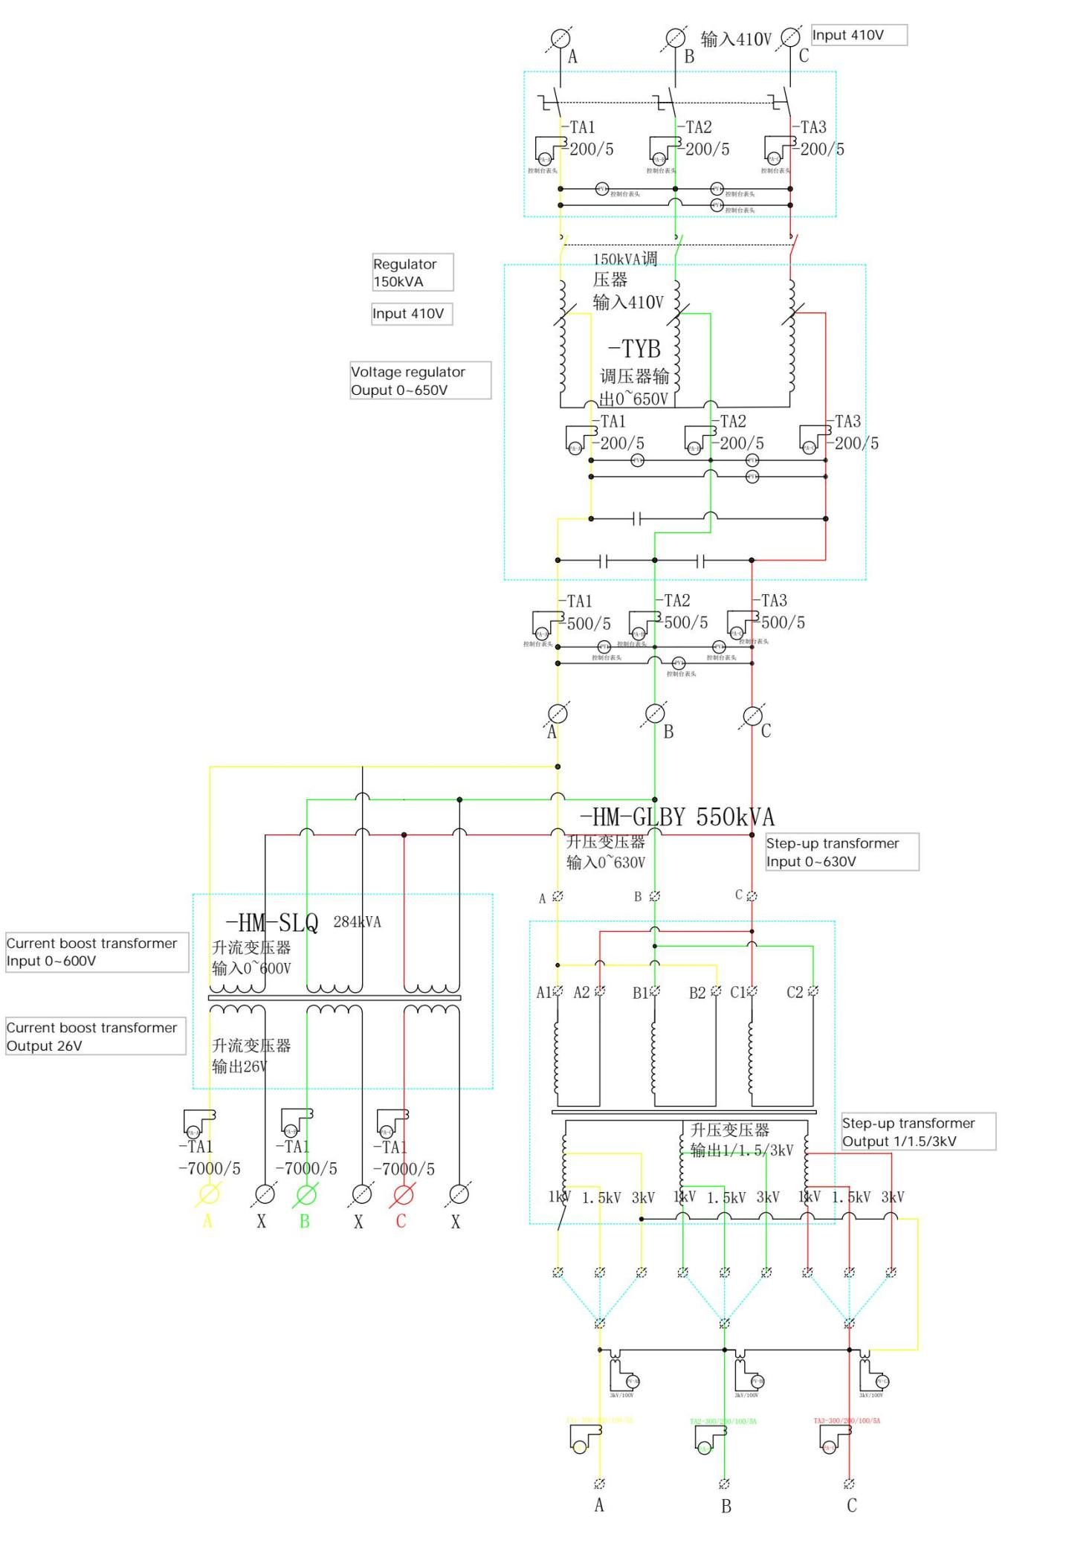

V Wire Connection
- Terminal of Automatic Console

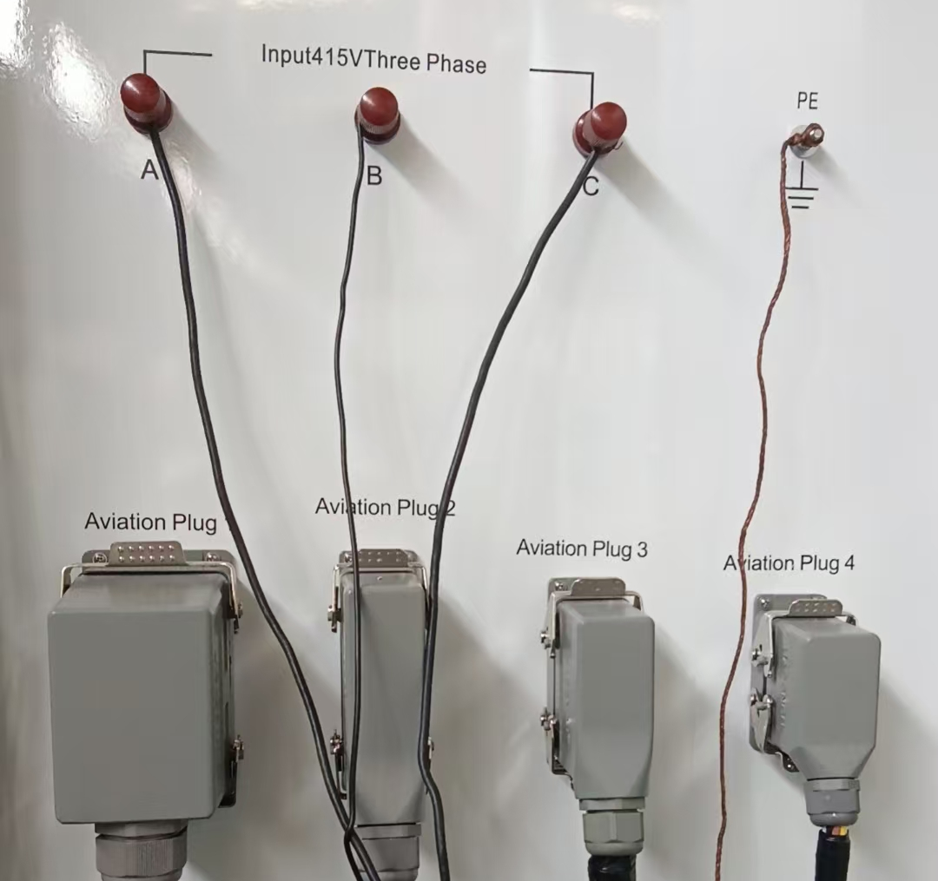

1 2 3 4

5 6 7 8

Item | Terminal | Connect with
1 | A phase | AC Power
2 | B phase | AC Power
3 | C phase | AC Power
4 | PE | Grounding of test lab
5 | Aviation Plug 1 | Input of compensation unit
6 | Aviation Plug 2 | Input of Temperature rise unit
7 | Aviation Plug 3 | Input of compensation unit
8 | Aviation Plug 4 | Input of primary current injection unit
9 | Temperature Tester | Temperature acquisition module

- Terminal of Compensation Unit-Input
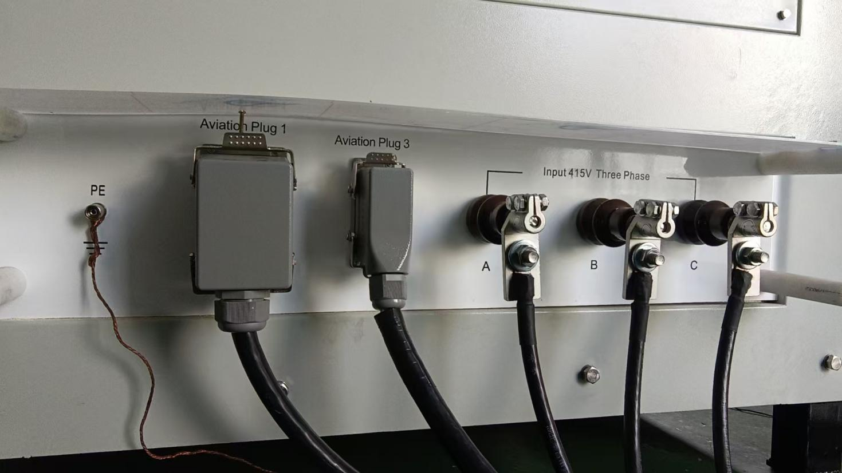
1 2 3 4 5 6

Item | Terminal | Connect with
1 | PE | Grounding of test lab
2 | Aviation Plug 1 | Console
3 | Aviation Plug 3 | Console
4 | A phase | A phase of Console
5 | B phase | B phase of Console
6 | C phase | C phase of Console

- Terminal of Compensation Unit-Output

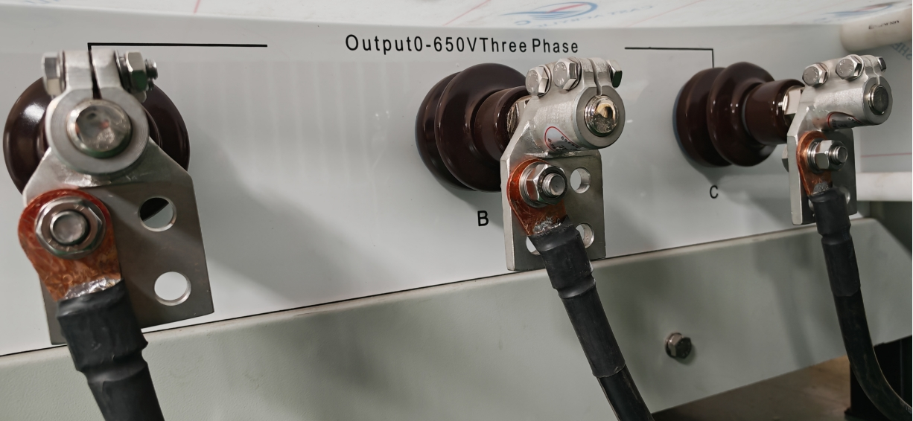
1 2 3
Item | Terminal | Connect with
1 | A phase | Temperature rise or Primacy current unit-A Phase
2 | B phase | Temperature rise or Primacy current unit-B Phase
3 | C phase | Temperature rise or Primacy current unit-C Phase

- Terminal of Temperature Rise Unit(Step-up Transformer)-Input
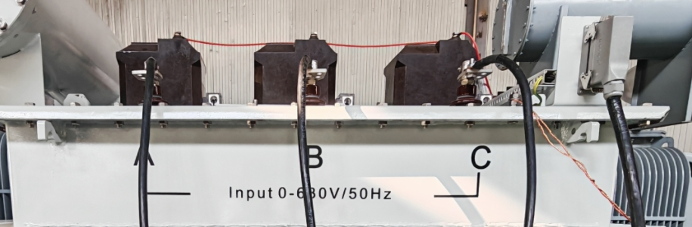
Item | Terminal | Connect with
1 | A phase | Compensation unit output-A Phase
2 | B phase | Compensation unit output-B Phase
3 | C phase | Compensation unit output-C Phase
4 | PE | Grounding of test lab
5 | Aviation Plug 2 | Console

- Terminal of Temperature Rise Unit(Step-up Transformer)-Output
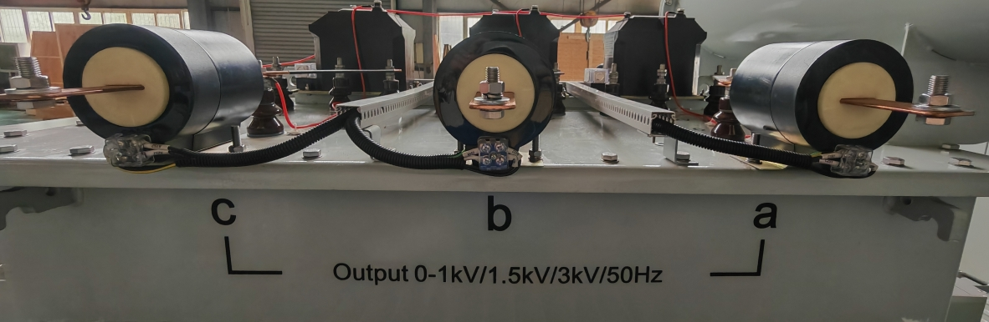
Item | Terminal | Connect with
1 | a phase | Tested object-A Phase
2 | b phase | Tested object-B Phase
3 | c phase | Tested object-C Phase

- Terminal of Temperature Rise Unit(Step-up Transformer)-Voltage Gear
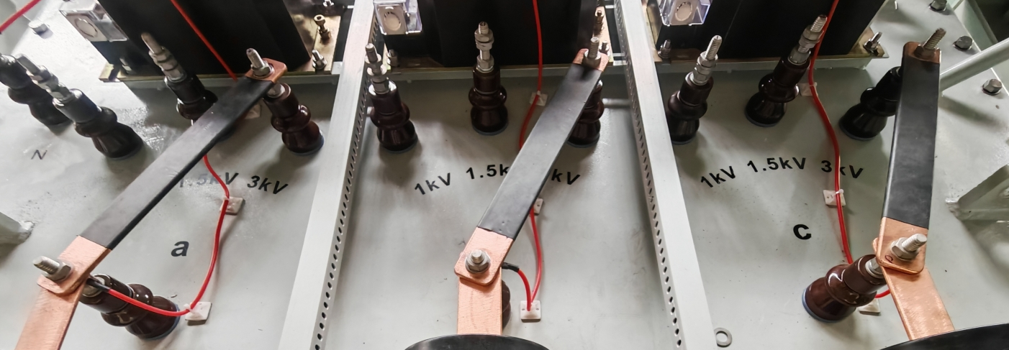

Item | Terminal | Connect with
1 | 1kV | Select the appropriate gear according to the test product
2 | 1.5kV | Select the appropriate gear according to the test product
3 | 3kV | Select the appropriate gear according to the test product
***The 3-phase gears need to be kept consistent, for example: 1kV for phase a, 1kV for phase b, and 1kV for phase c.
- Terminal of Primary Current Generator-Input
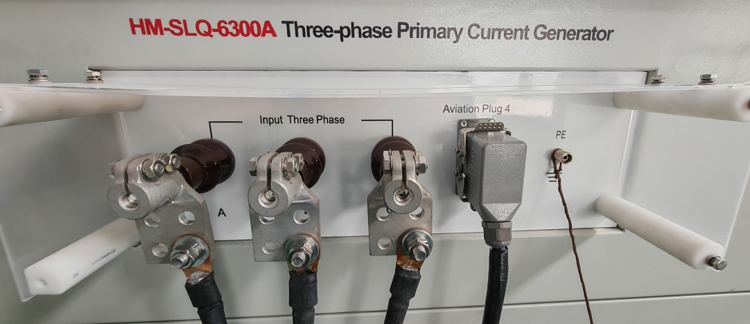
Item | Terminal | Connect with
1 | A phase | Compensation unit output-A Phase
2 | B phase | Compensation unit output-B Phase
3 | C phase | Compensation unit output-C Phase
4 | Aviation Plug 2 | Console
5 | PE | Grounding of test lab

- Terminal of Primary Current Generator-Output
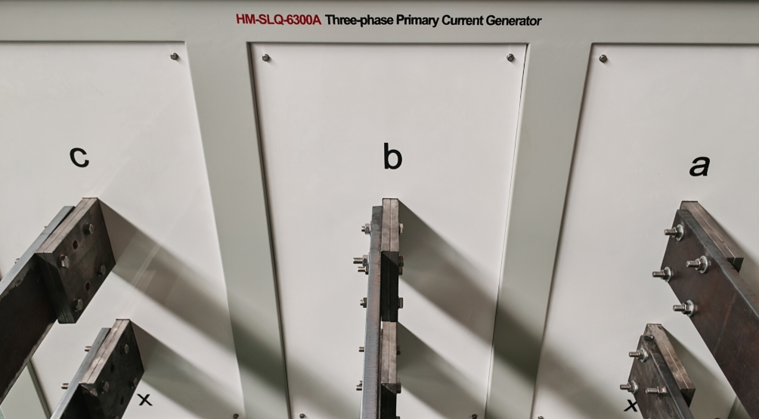
Item | Terminal | Connect with
1 | a phase | Compensation unit output-A Phase
2 | b phase | Compensation unit output-B Phase
3 | c phase | Compensation unit output-C Phase
4 | a phase-x | When the end of busbar can be short-circuited, the abc three-phase "x" needs to be short-circuited. When the end of busbar cannot be short-circuited, connect it to a”x”/b”x”/c”x” respectively.
5 | b phase-x
6 | c phase-x

VI Operation Instruction
- Main interface
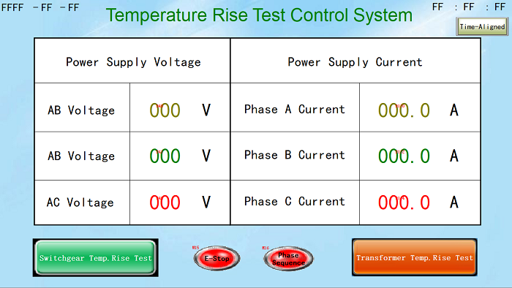
- The main interface (touch screen) has 4 parts, switch temperature rise test, transformer temperature rise test, emergency stop display, phase sequence protection display.
- Switchgear temperature rise test: enter the test interface
- Transformer temperature rise test: enter the test interface
- E-Stop: The console emergency stop button is unlocked, displayed in green, the console emergency stop button is not unlocked, displayed in red
- Phase Sequence: Phase sequence protection display, ABC three-phase wiring is correct, displayed in green, ABC three-phase wiring is incorrect, displayed in red
- Swithgear Temperature Rise Test
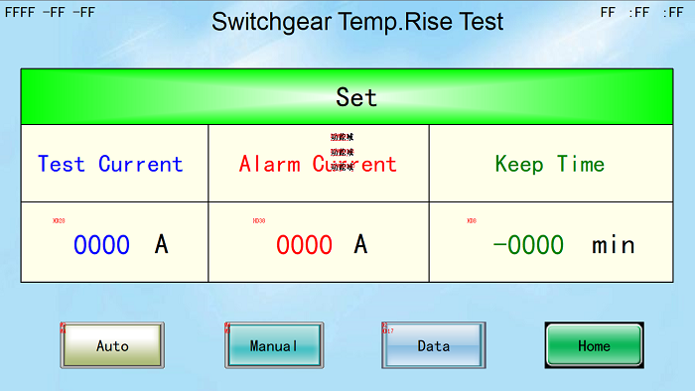

- Test Current: Set the test current according to the requirements of the test sample
- Alarm Current: Set the protection current, usually 1.1 times the test current, and pay attention to the peak output current of the testing system at this time
- Keep Time: Set the endurance time according to the experimental requirements
- Auto: Fully automatic test
- Manual: Manual test
- Data: Switch temperature rise test data query
- Home: Return to the main interface

2.1 Auto Test
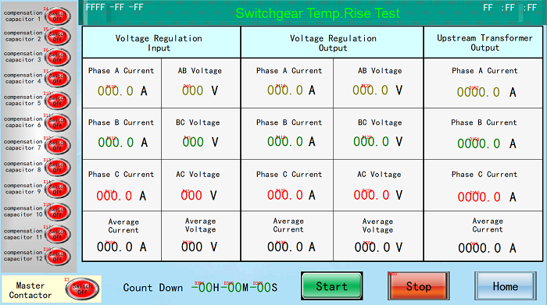
- Start: Click Start, the following interface will appear. Click Start, the device will automatically increase the current and withstand the current. After the test is completed, it will automatically decrease to zero.

- Stop: Used when you need to stop the test in the middle of the test.
- Home: Return to the previous menu interface

2.2 Manual Test
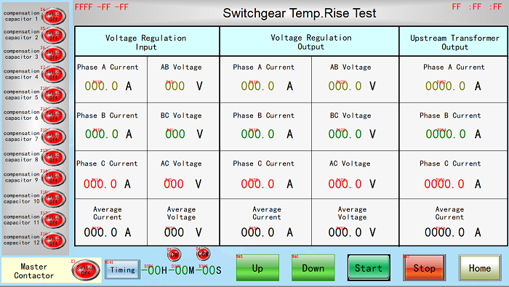
- Start: Click Start, the following interface appears, click Start
- Up: Current increase
- Down: Current drop
- Stop: Used when you need to stop the test in the middle of the test
- Home: Return to the previous menu interface

2.3 Test Data
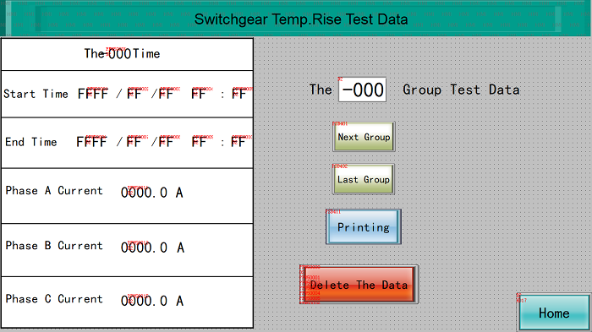
- Transformer Temperature Rise Test
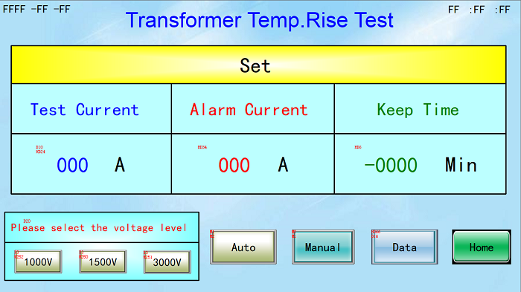
- Test Current: Set the test current according to the test product requirements
- Alarm Current: Set the protection current, usually 1.1 times the test current. At this time, pay attention to the peak output current of the test system
- Keep Time: Set the withstand time according to the test requirements
- Voltage Level: Voltage level 1000V/1500V/3000V, select the corresponding voltage level according to the test requirements
- Auto: Fully automatic test
- Manual: Manual test

3.1 Auto Test
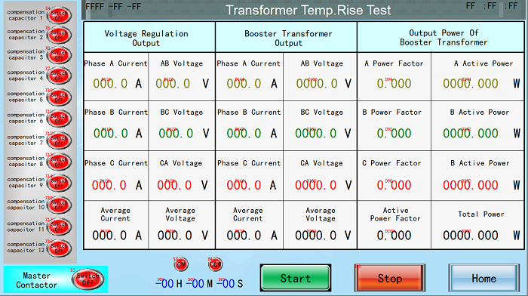

- Start: Click Start, the following interface will appear. Click Start, the device will automatically increase the current and withstand the current. After the test is completed, it will automatically decrease to zero.
- Stop: Used when you need to stop the test in the middle of the test.
- Home: Return to the previous menu interface

3.2 Manual Test
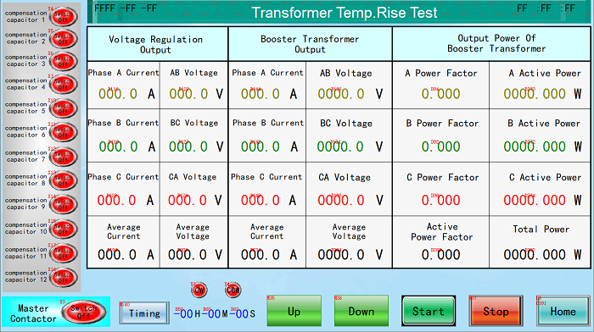
- Start: Click Start, the following interface appears, click Start
- Up: Current increase
- Down: Current drop
- Stop: Used when you need to stop the test in the middle of the test
- Home: Return to the previous menu interface

3.3 Test Data
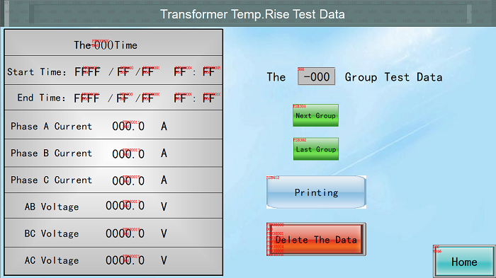

VII Maintenance
1.The equipment is used for continuous work, the rated capacity of the working power supply should be more than 1.5~2 times that of the equipment, and also pay attention to the main circuit loop terminals whether they have a losse. For short-term operation, it is sufficient to provide rated power supply.
2.When during storage for a long time, check the insulation resistance of the main circuit with 500 V mega meter before use, its resistance value is not less than 20 MΩ
3.Input voltage should be compliance with range 400~415V, frequency is 50Hz.
4.When the large current generator is outputting current (working operation), it is not allowed to switch operation with the tested product.
5. The working time at full load shall not exceed 24 hours.
6. There is grounded terminals in the primary current generator shell, and when doing, make sure it is grounded well.
7. The test lead lengths should not be too far from the secondary side of the primary current generator to the tested object, cross section should be reserved enough (Ampere density can be considered as 1.5-2A/mm). and the contact surface should be clean (applying conductive paste), otherwise, it will leads to the contact surface is too hot, and will not be up to the rated value.
8. There is no flammable substance in the working place, also prepare fire-fighting equipment during the working place.
9. When we are doing the long time running temperature rising test, there has to keep some operators watching. And also during this period, we have to check the equipment, test lead and contact surface’s performance regularly, and also write the records.
10. All the operation should be compliance with the safety working regulations of electrical industry and adopts the safety method according to the real situation.
11. During the current-up period, it is better to use uniform velocity, and when moving the equipment, also avoid the excessive vibration.
12. When using, keep the console, compensation(voltage regulator) and primary current generator are well grounded.

VIII Packing List Of Test System
No. | Item | Quantity
1 | Automatic Console | 1 pc
2 | Power Compensation Unit | 1 pc
3 | Primary Current Generator For Busbar | 1 pc
4 | Temperature Rise Generator For Transformer | 1 pc
5 | Power cable of console | 3pcs
6 | Aviation plug cable(10m/each) | 4pcs
7 | Power cable of Compensation unit(6m/each) | 3pcs
8 | Output cable of Compensation unit(6m/each) | 6pcs
9 | Temperature measurement module (24 probes) | 1set
10 | Earth Cable(50m) | 1set

